POINTER’S PROBLEMS

(M.SWATHI,192111059):

1)INTEGER POINTER:

#include<iostream>

using namespace std;

class A

{

public:

int a;

A()

{

a=10;

}

void display(){

cout<<a;

}

};

int main()

{

A b;

A \*c;

c=&b;

cout<<c->a;

}

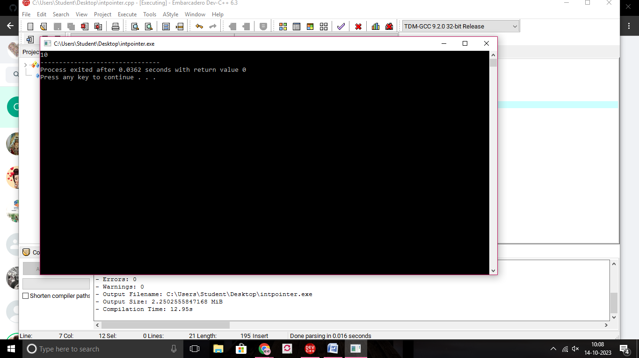

2)CHAR POINTER:

#include<iostream>

using namespace std;

class A

{

public:

char a;

A()

{

cout<<"enter char:";

cin>>a;

}

void display(){

cout<<a;

}

};

int main()

{

A b;

A \*c;

c= &b;

cout<<c->a;

}

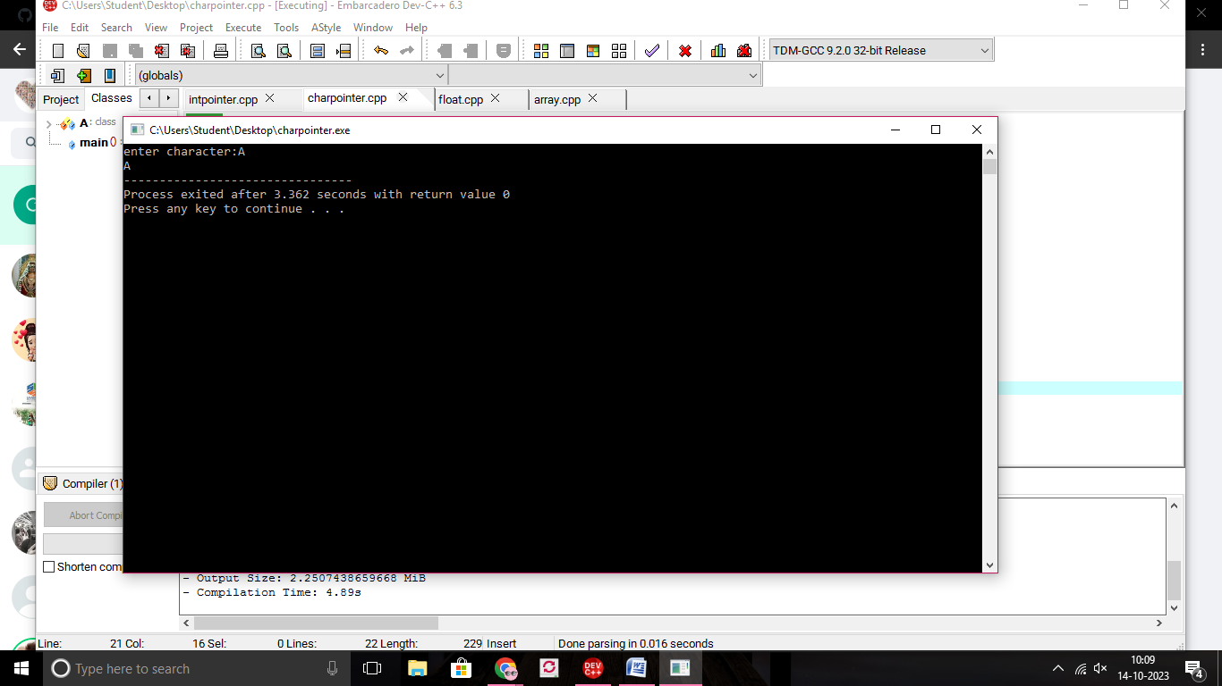

3)pointer to float:

#include<iostream>

using namespace std;

class A

{

public:

float a;

A()

{

cout<<"enter floatnum:";

cin>>a;

}

void display(){

cout<<a;

}

};

int main()

{

A b;

A \*c;

c= &b;

cout<<c->a;

}

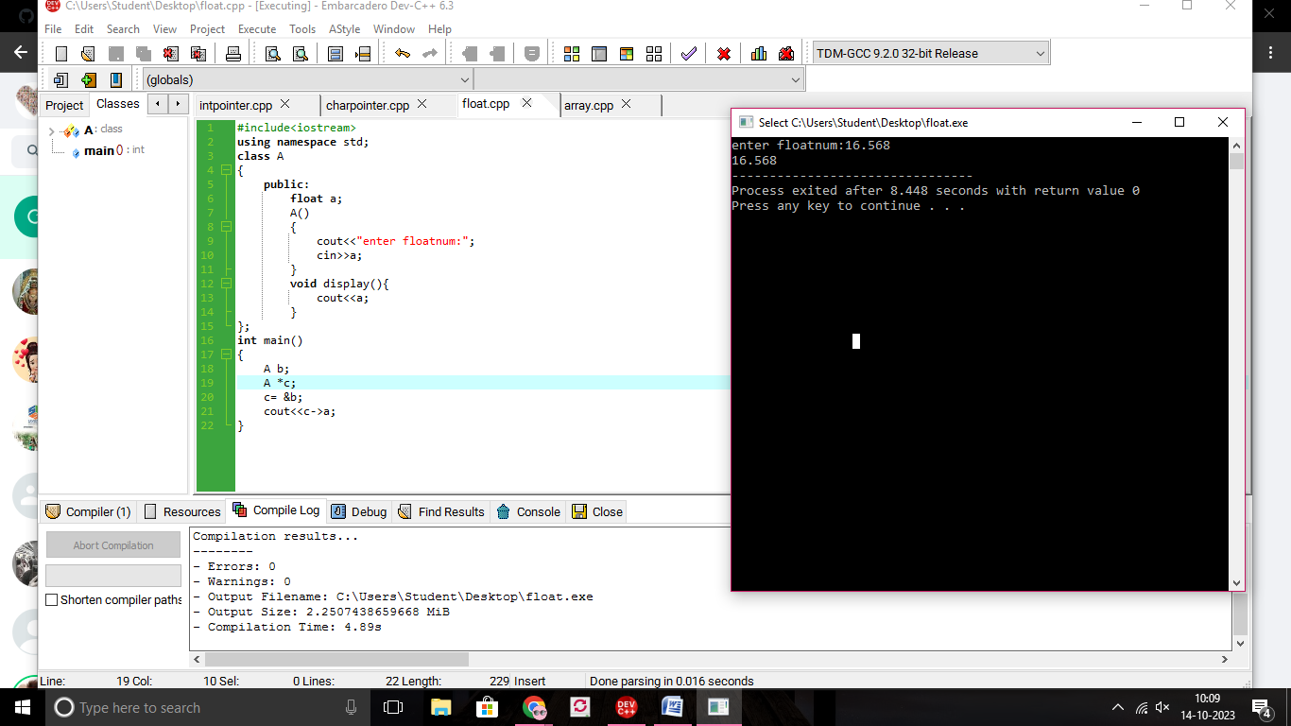

3

4)pointer to array:

#include<iostream>

using namespace std;

class A

{

public:

int a[100],n,i;

A()

{

cout<<"enter size of array:";

cin>>n;

cout<<"enter elements:";

for(i=0;i<n;i++)

{

cin>>a[i];

}

}

void display(){

for(i=0;i<n;i++)

cout<<a[i];

}

};

int main()

{

A b;

A \*c;

c= &b;

cout<<"array is:";

c->display();

}

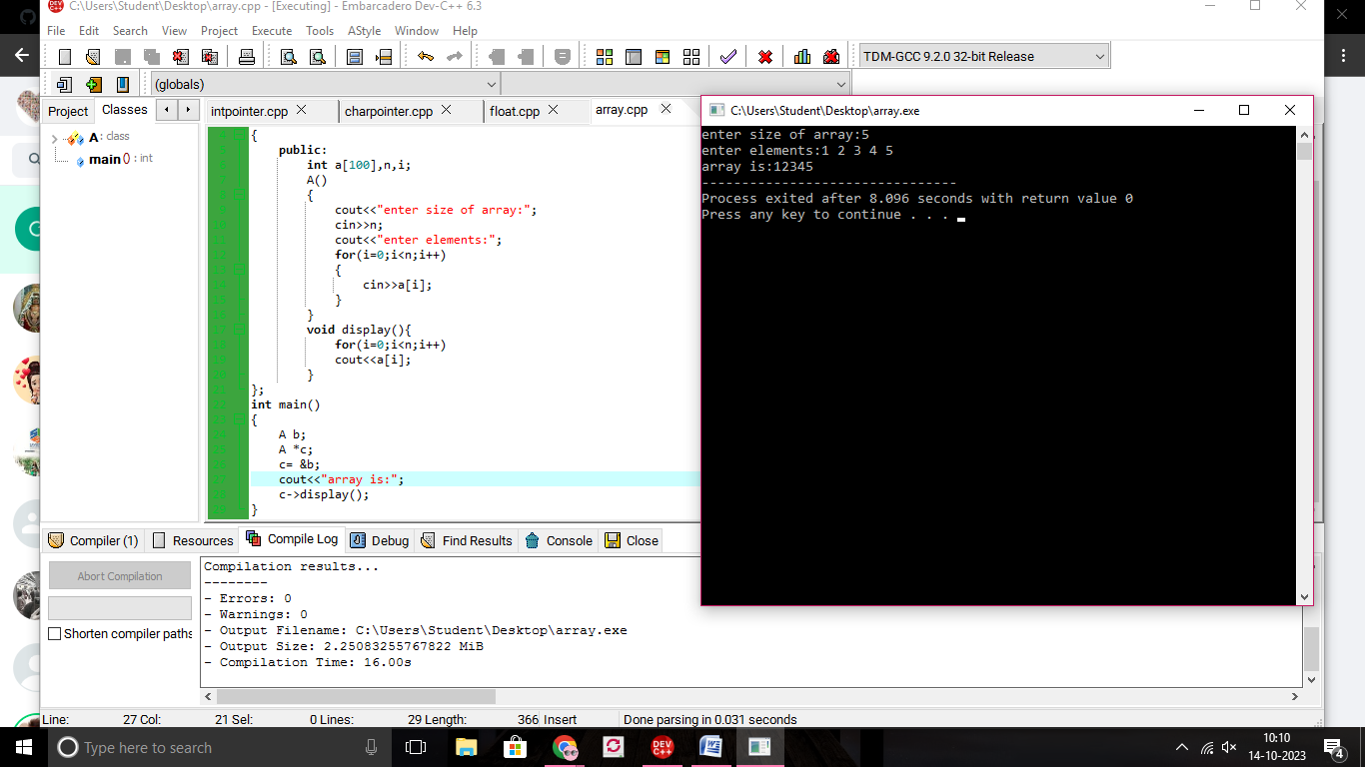

5)pointer to array character:

#include<iostream>

using namespace std;

class A

{

public:

char a[100];

int n,i;

A()

{

cout<<"enter size of array:";

cin>>n;

cout<<"enter elements:";

for(i=0;i<n;i++)

{

cin>>a[i];

}

}

void display(){

for(i=0;i<n;i++)

cout<<a[i];

}

};

int main()

{

A b;

A \*c;

c= &b;

cout<<"array is:";

c->display();

}

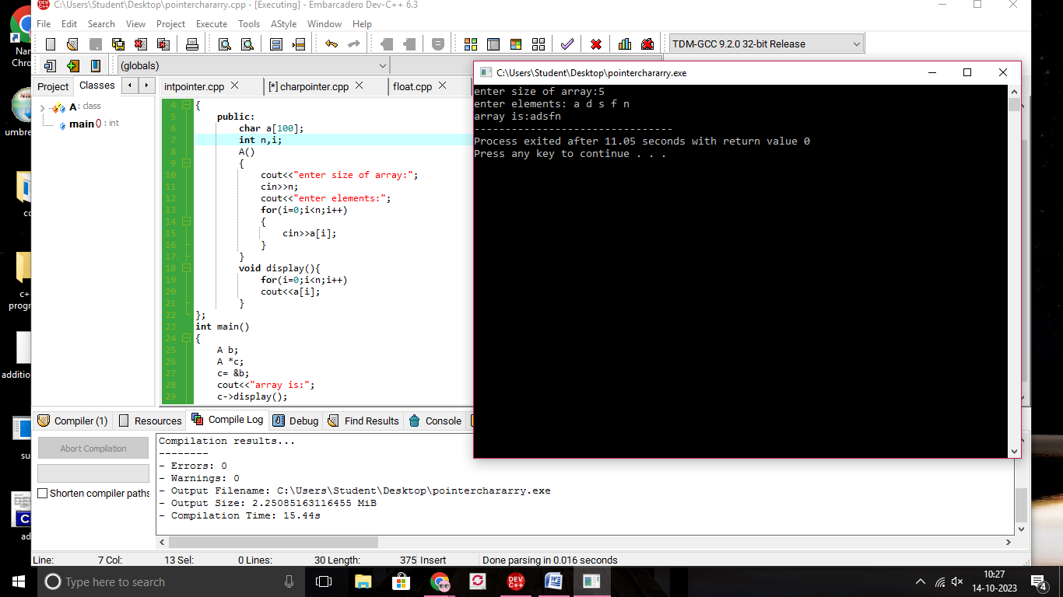

6)pointer to string:

#include<iostream>

using namespace std;

class A

{

public:

string a;

A()

{

cout<<"enter string:";

cin>>a;

}

void display(){

cout<<a;

}

};

int main()

{

A b;

A \*c;

c= &b;

cout<<c->a;

}

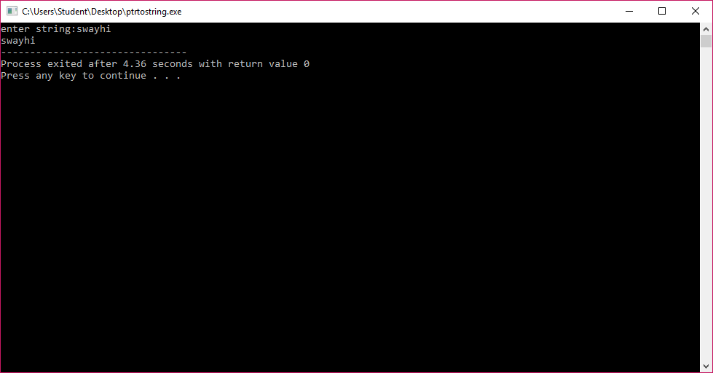

7)pointer to object:

#include<iostream>

using namespace std;

class A

{

public:

int a;

A()

{

a=10;

}

void display(){

cout<<a;

}

};

int main()

{

A b;

A \*c;

c=&b;

cout<<b.a<<"\n";

b.display();

cout<<"\n";

cout<<c->a<<"\n";

c->display();

}

